**Install R software**

Step 1: download base R (version R-3.6.1)

* For Windows (32/64 bit): click [here](https://cran.r-project.org/bin/windows/base/) to download
* For macOs (64-bit): click [here](https://cran.r-project.org/bin/macosx/) to download

Step 2: download RStudio (Rstudio Desktop Free)

* For Windows (64-bit): click [here](https://download1.rstudio.org/desktop/windows/RStudio-1.2.5001.exe) to download
* For macOs (64-bit): click [here](https://download1.rstudio.org/desktop/macos/RStudio-1.2.5001.dmg) to download

**Install necessary R packages**

* Open RStudio, you can see 4 panels as follow:

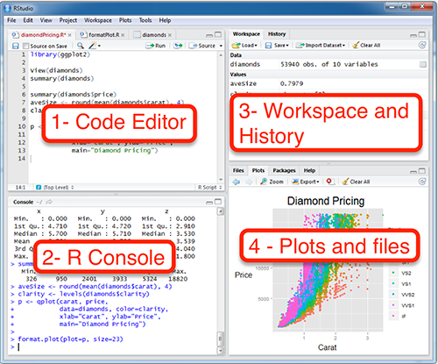

* Paste the following codes into the Code Editor panel:

*# Install packages*

*install.packages(c("devtools", "tidyverse", "knitr", "lme4", "plotly", "BayesFactor", "rstanarm"))*

*devtools::install_github("easystats/easystats")*

*# Load libraries*

*library(tidyverse)*

*library(easystats)*

*library(lme4)*

*library(plotly)*

*library(BayesFactor)*

*library(rstanarm)*

* Or alternatively, if you are familiar with running R files, simply run the attached R file (“install_packages.R”)